

ROLE PROFILE
CLIMBING INSTRUCTOR – LEGACY YOUTH ZONE



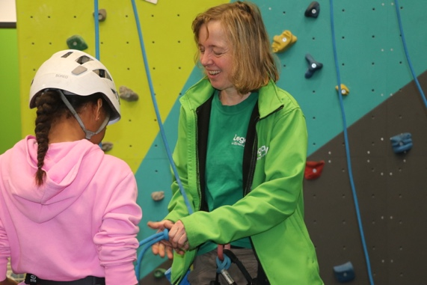
Climbing Instructor

Legacy Youth Zone and The BRIT School Partnership

£35 per hour | Wednesdays | Term Time Only

The opportunity
Legacy Youth Zone is looking for an enthusiastic and suitably qualified Climbing Instructor to deliver weekly climbing sessions for Year 10 students from The BRIT School, as part of their BRIT Fit Sports and PE Programme.

Working from our purpose-built indoor climbing wall at Legacy Youth Zone, Croydon, you'll create a safe, inclusive and engaging environment where young people can challenge themselves, develop their climbing abilities and enjoy being active.

Role details
Location | Legacy Youth Zone, Whitehorse Road, Croydon
Pay | £35 per hour
Hours | Wednesdays, 2:45pm–4:15pm (1.5 hours per week)
Working pattern | Term time only, following The BRIT School's term dates
Session time | 15 minutes setup, 60 minutes delivery and 15 minutes pack-down
Contract | Fixed term (we would also be open to hearing from applicants who are self employed
Dates | Start ASAP - Full schedule of delivery term dates available

What you'll be doing
- Deliver engaging, age-appropriate climbing sessions for Year 10 students, catering to different abilities and levels of experience
- Support young people to develop climbing techniques, confidence, teamwork and resilience.
- Provide appropriate instruction, supervision and guidance to ensure the safe use of the climbing wall.
- Carry out necessary safety checks of climbing equipment, including ropes, harnesses and belay systems.
- Ensure climbing equipment is set up, maintained, stored and secured appropriately.
- Work collaboratively with Legacy staff and The BRIT School team to deliver a positive experience for students.
- Follow Legacy's safeguarding, health and safety and equality policies, reporting any concerns or incidents appropriately and the Brit School’s ‘Hands On’ policy

What we're looking for
We're keen to hear from people who:
- Hold a relevant climbing instructor qualification that permits them to supervise and instruct on an indoor climbing wall.
- Have experience delivering climbing activities, ideally with children or young people.
- Are confident supporting groups with different abilities, including beginners.
- Have a positive, encouraging and inclusive approach to working with young people.
- Understand the importance of safeguarding, risk assessments and safe climbing practices.
- Can commit to regular Wednesday sessions during The BRIT School's term time.
We welcome enquiries from applicants with different climbing qualifications and experience. Please tell us about your qualifications when applying so we can assess their suitability for our climbing wall and the programme.

About Legacy Youth Zone
Legacy Youth Zone is an award-winning youth charity based in the heart of Croydon, providing a safe, inspiring and inclusive space for young people aged 8–19, and up to 25 for those with additional needs.
Open seven days a week, Legacy offers young people opportunities to discover new interests, develop skills, build friendships and reach their potential through sports, arts, music, employability and youth work programmes.

How to apply
Closing date: Open until the position is filled.
To apply, please submit a recent CV, evidence of climbing qualification and a short cover letter. This needs to be emailed to businesssupport@legacyyouthzone.org
Applications will be reviewed as they are received, and suitable candidates may be invited to interview before the position closes.
Safeguarding: Legacy Youth Zone is committed to safeguarding and promoting the welfare of children and young people. Appointment will be subject to appropriate safer recruitment checks, including an enhanced DBS check and satisfactory references.
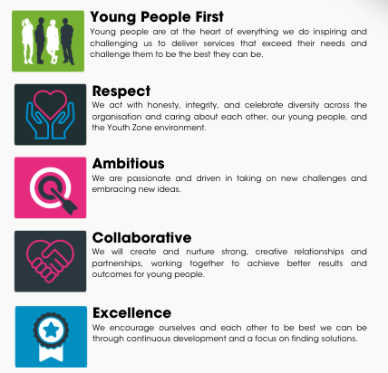
OUR VALUES

6

