


ROLE PROFILE
COOK & CATERING ASSISTANT
LEGACY YOUTH ZONE


ROLE PROFILE

POST:
Cook and Catering Assistant

SALARY:
£13.85 per hour

LOCATION:
Legacy Youth Zone, Croydon
REPORTING TO:
Youth Work Operations Manager

LINE REPORTS:

None

CONTRACTED HOURS AVAILABLE: (Multiple roles)
- Tuesdays 3:45 pm -8 pm
- Wednesdays 4:45 pm 9 pm
- Thursdays 3:45 pm - 8 pm
- Friday 4:45 pm 9 pm
- Saturday AM 11:45 am-3 pm
- Saturday PM 4:45 pm-9 pm
- Sunday 2.30 pm – 6.30 pm

Please see the proposed shift pattern below (available for flexibility)

COOK AND CATERING ASSISTANT-1
  - Tuesdays 4 pm -8 pm
  - Thursdays 4 pm - 8 pm
  - Friday 4 pm-8 pm
  - Saturday 5 pm-9 pm

COOK AND CATERING ASSISTANT-2

  - Wednesdays 4 pm 8 pm
  - Thursdays 4 pm - 8 pm
  - Saturday AM 11:45 am-3.15 pm
  - Sunday 2.30 pm – 6.30 pm

BENEFITS:
33 days annual leave (pro-rata), inclusive of bank holidays pro-rata; free gym access; access to Onside’s Talent Academy; Employee Assistance Programme; free staff meals during sessions; discounted holiday club for dependants on working days

KEY RELATIONSHIPS:
Operations Manager, Facilities Officer, Youth Zone Staff, Young People, Duty Managers and Club Leaders, Parents

MAIN PURPOSE:
The purpose of the role as Cook and Catering Assistant is to prepare and cook healthy, cultural & tasty meals from our ‘Big Love Kitchen’ to 100+ young people and their families on our Sunday Beyond Limits SEND session for young people with additional needs. Healthy, creative, and fun food is at the core of what we offer, creating an opportunity for young people and their families/support workers to eat together. Young people attend sessions and can engage in a wide variety of activities whilst being able to purchase a hot meal for just £1 as well as a variety of tuck shop snacks!

As this role will require staff to engage with young people up to the age of 25, applicants for this role must be over the age of 21.

CORE RESPONSIBILITIES

Detailed
- To undertake the preparation and cooking of food and beverages served in the café / tuck area
- To serve food and beverages to Legacy Youth Zone members, ensuring they receive a great level of customer service.
- To assist with the production of menus
- To comply with stock control procedures
- Ensure all kitchen equipment is regularly cleaned, reporting any faults/repairs required.
- Ensure all Health and Safety and Environmental Health requirements are adhered to
- Reporting of any health and safety issues
- Compliance with food hygiene and food standard regulations
- Recording temperatures on delivery of all high-risk food and prior to service, where applicable
- Cash handling in line with Legacy financial procedures
- Clearing tables and washing up
- Any other duties that may be required
General
- Be a role model for young people and present a positive “can do” attitude
- Take personal responsibility for own actions
- Commit to a culture of continuous improvement
- Represent Legacy Youth Zone positively and effectively in all dealings with internal colleagues, and external partners
- Comply with all policies and procedures, with particular reference to safeguarding, codes of conduct health and safety and equality and diversity
- To be alert to issues of safeguarding and child protection, ensuring the welfare and safety of Youth Zone members is promoted and safeguarded, and to report any concerns (training to be provided)
- To assist with any promotional activities and visits that take place at the Youth Zone including special events and community days
- To carry out any other reasonable duties as requested by the Senior Managements

ABOUT LEGACY YOUTH ZONE
Croydon Youth Zone, named “Legacy” by local young people, was the third Youth Zone in
London opened by the national charity, OnSide in September 2019. Legacy, like all OnSide
Youth Zones, exists to give young people somewhere to go, something to do and someone to
talk to. It’s about opportunity.
Legacy’s state-of-the-art £6.5 million building on Whitehorse Road, provides young people with access to a range of activities, offering them the opportunity to try new things, meet new friends and gain support from friendly, warm and positive staff and volunteers. The facilities include a 3G pitch, a gym, sports hall, recreation area and dance, arts, music and media suites, with facilities equipped for a wide range of sporting, artistic, cultural and general recreational activities and targeted services. To access a Youth Zone, young people aged 8 – 19 (or 25 with additional needs) simply pay 50p per visit and £5 per year membership.
To find out more, please watch this video: https://www.youtube.com/watch?v=usP0DSRw7nw

ABOUT ONSIDE
Potential is everywhere. In every home on every street, from affluent suburbs to inner-city estates. The difference is that some young people get every opportunity to explore their potential. Others don’t.
OnSide is a national charity that believes all young people should have the opportunity to discover their passion and their purpose. To find out what they’ve got and where it could take them.
OnSide funds and builds state-of-the-art, multimillion- pound Youth Zones in the country’s most economically disadvantaged areas. They train the amazing people that run them. And they offer continuing support via the nationwide OnSide Network of 14 Youth Zones (and growing), where colleagues can learn and grow, share their stories, and celebrate their success together.
This is passionate, properly funded youth provision, with no ifs or buts. A unique partnership between young people and their community, local authorities and private business leadership, and a growing movement of supporters who believe that how we treat the next generation defines who we are as a society.

PERSON SPECIFICATION
Applicants will be expected to demonstrate the following experience, skills, knowledge, and attributes.

SELECTION CRITERIA

EXPERIENCE
Experience of working in a catering environment | Essential
Experience as cook within a commercial kitchen | Essential
Knowledge of Health, Safety and Environmental issues | Essential
Working in an environment that involves dealing with the public | Essential
Food Hygiene Certificate & Health & Safety L2 Certificate (Training Available ) | Desirable
Experience of working with young people | Desirable

SKILLS, KNOWLEDGE AND ATTRIBUTES
Excellent organisational, communication and interpersonal skills | Essential
Willingness to support the Youth Work team in ensuring a safe, fun and welcoming environment for all young people | Essential
Ability to work on own initiative and as part of a team | Essential
Knowledge of safeguarding | Desirable
Punctual and reliable | Essential

OTHER REQUIREMENTS
A willingness to occasionally support with overtime opportunities to cover holidays and absences | Desirable
Enhanced DBS clearance (will be provided and paid for by Legacy) and committed to Safeguarding children | Essential
A commitment to mission of Legacy Youth Zone to transforming the lives of young people, by giving them somewhere to go, something to do and someone to talk to. | Essential

APPLICATION PROCESS
If you’re excited about this role but your past experience does not align perfectly with every requirement in the person specification, we encourage you to still apply and demonstrate how your experience is transferrable for this role. You may be just the right candidate.

To apply, please complete the online application process (submitting a cover letter and CV), which can be found through our website or by clicking here. Please inform us if there are any reasonable adjustments, we can make to assist you in your application or the selection process.

This role will be based in the Youth Zone and therefore require an Enhanced DBS and references upon being offered the post.

Anonymous Applications: We recognise our workforce is under-represented in certain areas and are committed to addressing this. Therefore, we actively encourage applicants to submit anonymous applications; this means removing names & email addresses from CVs and cover letters. The HR Manager will have this information from submissions, but this will not be available to the selection panel when they are considering applications.
For information on how Legacy processes your data, go to https://legacyyouthzone.org/privacy-policy/

OUR VALUES

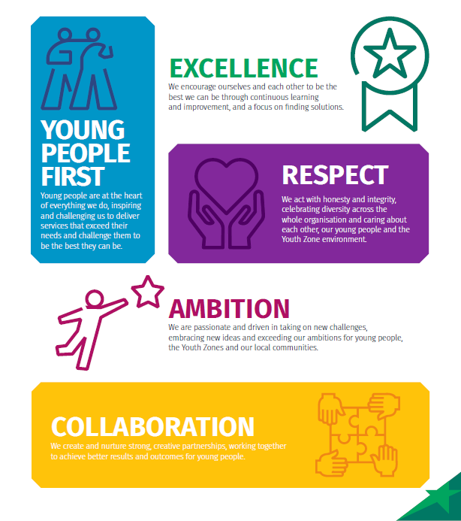

6

