

**ROLE PROFILE**  
**SCHOOL ENGAGEMENT PROGRAMME**

**YOUTH MENTOR**

**LEGACY YOUTH ZONE**

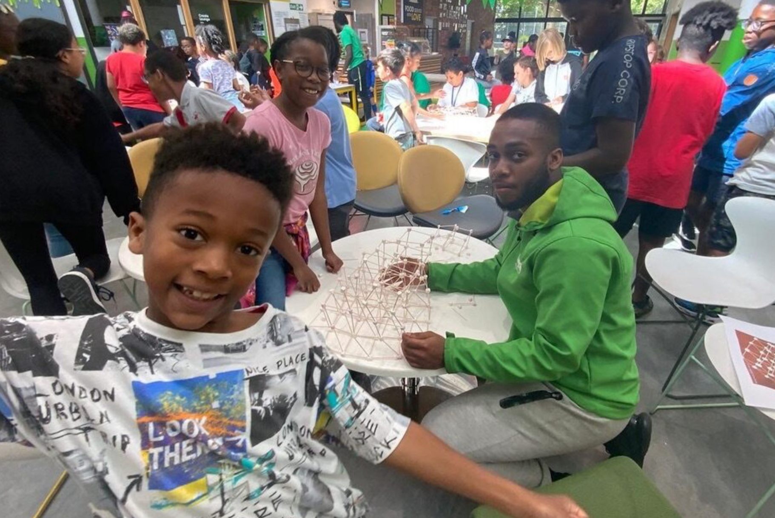**ROLE PROFILE**

## POST:

School Engagement Youth Mentor

## CONTRACT:

Part-Time, 8 hours per week

Fixed Term to July 2027

## SALARY: £13.85 ph

## LOCATION:

Legacy Youth Zone, Croydon. CR0 2LG

School Partner sites (travel expenses covered)

**REPORTING TO:**

School & Community Engagement Manager

## BENEFITS:

33 days annual leave including bank holidays (pro-rata); free gym access; Employee Assistance and Wellbeing Programme; free staff meals during sessions; discounted holiday club for dependants on working days; external clinical supervision, flexible working and access to OnSide Talent Academy training and development programme.

**KEY RELATIONSHIPS:**

Senior Leadership Team, School and Community Engagement Team, Head of Youth Work and Partnerships, Youth Work Management Team, Youth Workers, Young People and Parents/Carers, Volunteers, School Partner leads

**MAIN PURPOSE**

Legacy Youth Zone is a vibrant, inclusive space where young people can grow, thrive, and feel supported. We work in partnership with local schools and Reedham Children’s Trust through the School Engagement Programme, which supports students who would benefit from additional guidance by providing mentoring both in school and at the Youth Zone, where they can access a wide range of extracurricular activities to help build confidence. We are seeking a dedicated and motivated Youth Mentor to join our School Engagement Team. The successful candidate will deliver one-to-one and group mentoring sessions with identified students during school hours and continue this support at Legacy Youth Zone. You will act as a positive role model, helping young people to develop confidence, emotional resilience, and a strong sense of purpose.

**CORE RESPONSIBILITIES:**

* Deliver one-to-one and small group mentoring sessions in schools (term time during school hours).
* Support and encourage mentees to attend Legacy Youth Zone after school.
* Liaise with school contacts and teachers with regard to referrals into the programme
* Continue mentoring support with young people informally during Youth Zone activities, supporting positive social interactions and personal development.
* Build and maintain strong relationships with young people, school staff, and youth workers.
* Record session notes and contribute to ongoing assessments of young people's progress.
* Promote the values and opportunities of the Youth Zone to mentees.
* Ensure a safe, inclusive, and supportive environment at all times.
* Attend team meetings and training sessions as required.

**GENERAL RESPONSIBILITIES**

* Be a role model for young people and team members
* Demonstrate personal accountability by taking responsibility for your own actions and decisions in line with organisational values and policies
* Represent the Youth Zone positively and effectively in all dealings with internal team members, and external partners
* To assist and, where necessary lead, on any promotional activities and visits that take place at the Youth Zone
* Contribute to a culture of continuous improvement, personally and professionally
* To actively promote the Youth Zone and positively contribute towards increasing Youth Zone membership and partnership opportunities
* Champion young people within the organisation, ensuring all services provide a great experience.
* To present a positive ‘can do’ attitude at all times

**Safety and Safeguarding**

* Contribute to ensuring the Youth Zone remains a safe and welcoming environment for young people, upholding high standards of behaviour as part of a team effort
* Be alert to issues of safeguarding and child protection, ensuring the welfare and safety of Youth Zone members is promoted and safeguarded

# SELECTION CRITERIA

Applicants will be expected to demonstrate the following experience, skills, knowledge, and attributes.

|  |  |
| --- | --- |
| **Experience** |  |
| Experience working directly with young people in mentoring support or youthwork roles | Essential |
| Experience building trusting professional relationships with young people from diverse backgrounds | Essential |
| Understanding of safeguarding and child protection issues, and the appropriate ways to respond to them | Essential |
| Effectively contributing to a positive workplace culture and seeking continuous improvement | Essential |
| Ability to Maintain boundaries and handle challenging behaviour calmly and professionally | Desired |
| Familiarity with child development principles and youth work values | Desired |
| Experience working in Holiday schemes, after school clubs, or similar youth led environments | Desired |
| **Skills, knowledge and attributes** |  |
| Ability to pay attention to detail, be thorough and well organised | Essential |
| Knowledge and understanding of the national and local issues facing young people, alongside an understanding of contextual safeguarding and the youth work process. | Essential |
| A commitment to the mission, aims and values of Legacy Youth Zone, a knowledge of the youth & voluntary sector in Croydon and what it has to offer to the wider community | Essential |
| Awareness of equality, diversity and inclusion,(EDI, understanding the barriers faced by young people from different backgrounds and a commitment to inclusive practice | Essential |
| Enhanced DBS clearance and commitment to Safeguarding children | Essential |
| Knowledge of educational settings - awareness of how schools operate, and the roles community partners play within them | Essential |
| Communication skills – ability to listen actively, communicate clearly and adapt to the needs of young people | Essential |
| Ability to work collaboratively with school staff and external partners | Essential |

# APPLICATION PROCESS

# Team members who wish to apply for this role must submit an expression of interest (cover letter) to demonstrate how they will meet the role specification and responsibilities via our website or by clicking the link [here](https://app.smartsheet.com/b/form/d9b44483885d4cf6acdd17905966571e).

For information on how Legacy processes your data, go to <https://legacyyouthzone.org/privacy-policy/>

**OUR VALUES**

6