ROLE PROFILE
MARKETING & COMMUNICATIONS MANAGER (MATERNITY COVER) - LEGACY YOUTH ZONE

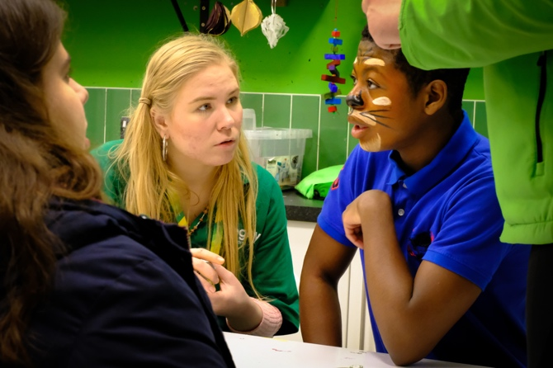
ROLE PROFILE

POST:
Marketing and Communications Manager (Maternity Cover)

SALARY:
£30,000 to £32,000 dependent on experience

LOCATION:
Legacy Youth Zone, Croydon
REPORTING TO:
Head of Fundraising and Communications

CONTRACT:
40 Hours per week including flexibility to work evenings and weekends on occasions. Time in lieu will be given.
This is a 1-year fixed term contract.

BENEFITS:
33 days annual leave including bank holidays pro-rata; free gym access; access to OnSide’s Talent Academy; Employee Assistance and Wellbeing Programme; free staff meals during sessions; discounted holiday club for dependants on working days

KEY RELATIONSHIPS Young people, Parents/Carers, Trustees, CEO, Youth Work Team, Volunteers, Partners, Local & regional media.

MAIN PURPOSE

This post leads on Marketing and Communications and plays a vital role in developing the key messages to be used by the
fundraising team wider charity, external positioning to raise awareness to key audiences of. Legacy as a life changing vital
local charity.
Target audiences are:
• Potential supporters
• Young people and their families, members, and potential members of the Youth Zone.
• The wider Croydon Community.
• Delivery partners

CORE RESPONSIBILITIES
• Deliver the marketing and communications strategic plan.
• Feed into the fundraising strategy to ensure we share our impact to funders and potential supporters.
• Raise awareness of the Youth Zone’s brand, work and impact.
• Create fun and vibrant content across our social media channels.
• Provide oversight and support to the Universal Youth Work Manager to deliver effective communications to parents and members.
• Capture inspiring stories on the life of our youth zone.
• Build the Youth Zone brand, ensuring consistency of presentation.
• To monitor and evaluate our performance across digital platforms.
• Develop email campaigns and potential postal journeys for donors and members.
• Support and lead events for young people, community, and donors.
• Comply with all policies and procedures, with reference to safeguarding, fundraising regulation, codes of conduct, health and safety, and equality and diversity and ensure we comply with GDPR standards.
• Be an active member of the team, carrying out any other reasonable duties as requested by the management team, and operating in line with the values and principles of the Youth Zone.
• Work with OnSide and other Youth Zone Communications Managers to share best practice and support Network wide campaigns and activities, as an active part of the OnSide Network Communications Forum.
• Work flexibly and inclusively (including evening and weekends as required) to ensure you can successfully delivery the agreed objectives of this role.

GENERAL RESPONSIBILITIES
- Be a role model for young people and present a positive “can do” attitude.
- Take personal responsibility for own actions.
- Commit to a culture of continuous improvement.
- Work within the performance framework of Legacy Youth Zone and OnSide.
- Represent the Youth Zone positively and effectively in all dealings with internal colleagues, and external partners.
- Comply with all policies and procedures, with particular reference to safeguarding, codes of conduct health and safety and equality and diversity to ensure all activities are accessible.

- Represent the Youth Zone positively and effectively in all dealings with internal colleagues, and external partners.
- To be alert to issues of safeguarding and child protection, ensuring the welfare and safety of Youth Zone members is promoted and safeguarded, and to report any child protection concerns to the designated
- Child Protection Officers
- To assist with any promotional activities and visits that take place at the Youth Zone.
- To actively promote the Youth Zone and positively contribute towards increasing Youth Zone membership.

ABOUT LEGACY YOUTH ZONE
Croydon Youth Zone, named “Legacy” by local young people, was the third Youth Zone in London opened by the national charity, OnSide in September 2019. This is an exciting and unique opportunity to join a small but growing, impactful fundraising team and play a critical part in shaping opportunities for London’s young people and supporting a grass roots, committed universal youth service.
Legacy, like all OnSide Youth Zones, exists to give young people somewhere to go, something to do and someone to talk to.
Legacy’s state-of-the-art £6.5 million building on Whitehorse Road, provides young people with access to a range of activities, offering them the opportunity to try new things, meet new friends and gain support from friendly, warm and positive staff and volunteers. The facilities include a 3G pitch, a gym, sports hall, recreation area and dance, arts, music and media suites, with facilities equipped for a wide range of sporting, artistic, cultural and general recreational activities and targeted services. To access a Youth Zone, young people aged 8 – 19 (or 25 with additional needs) simply pay 50p per visit and £5 per year membership.
To find out more, please watch this video: https://www.youtube.com/watch?v=usP0DSRw7nw

ABOUT ONSIDE
Potential is everywhere. In every home on every street, from affluent suburbs to inner-city estates. The difference is that some young people get every opportunity to explore their potential. Others don’t.
It’s about opportunity.
OnSide is a national charity that believes all young people should have the opportunity to discover their passion and their purpose. To find out what they’ve got and where it could take them.
OnSide funds and builds state-of-the-art, multimillion- pound Youth Zones in the country’s most challenging areas. They train the amazing people that run them. And they offer continuing support via the nationwide OnSide Network of 14 Youth Zones (and growing), where colleagues can learn and grow, share their stories, and celebrate their success together.
This is passionate, properly funded youth provision, with no ifs or buts. A unique partnership between young people and their community, local authorities and private business leadership, and a growing movement of supporters who believe that how we treat the next generation defines who we are as a society.
Because when we really invest in young people, we all benefit – from who they are now, everything they might become and achieve, and everyone they might touch and inspire.
All they need is the chance to shine – an environment where they can be their best selves –and you just watch them go.
It’s about opportunity.

PERSON SPECIFICATION
Applicants will be expected to demonstrate the following experience, skills, knowledge, and attributes.
Selection Criteria*  A = Application Form I = Interview T = Test/Personality Profile | Essential or Desirable | Method of Assessment

Experience
Proven Marketing & Communications (minimum 3 years) Essential  Experience of planning and managing income generating campaigns – including monitoring budgets and expenditure. | Essential | A & I
Varied experience of planning and delivering communication and creative marketing plans in line with organisational objectives and aims. | Essential | A & I
Experience of using a CRM system for logging and tracking fundraising activity. | Essential | A & I
Experience of working with the media and delivering PR and publicity with local and regional media outlets. | Essential | A & I
Experience of web content development and website management. | Essential | A & I
Experience managing externally funded projects. | Desirable | A & I
Experience of monitoring and evaluation processes. | Desirable | A & I
Experience providing information, advice, guidance and support to young people. | Desirable | A & I

Skills
Good numeracy skills and ability to analyse and report on your own financial performance. | Essential | A & I
Excellent written communication skills. | Essential | A & I
Knowledge of relevant IT systems e.g. Mailchimp; Hootsuite. | Essential | A & I
Thorough and accurate with excellent attention to detail | Essential | A & I
Knowledge of content creation and design programmes such as Adobe or Canva Essential | Essential | A & I
Knowledge of developing digital ad campaigns on Google Grants, Meta Ads etc Desirable | Essential | A & I
Able to work flexibly and under own initiative to ensure deadlines are met and tasks are prioritised. | Essential | A & I
Able to communicate effectively with a range of stakeholders. | Essential | A & I

Knowledge
Knowledge and awareness of issues affecting young people | Essential | A & I
Knowledge of how to segment audiences and optimise fundraising messaging to raise awareness  among different stakeholders and receive return donations | Essential | A & I
Willing to develop knowledge of fundraising best practice, legal requirements and health and safety related to individual giving | Essential | A & I
Knowledge of Marketing and Comms approaches to engage with key stakeholders | Essential | A & I
Good working knowledge of MS Office. | Essential | A & I
Knowledge of health and safety, diversity awareness and safeguarding best practice and how these relate to children and young people | Desirable | A & I

Special Requirements
Passion for raising money for a charity working with children and young people Essential | Essential | A & I
Enthusiasm and ability to contribute to the successful development of The Youth Zone. | Essential | A & I
Enhanced DBS clearance and commitment to Safeguarding children | Essential | A & I

APPLICATION PROCESS
To apply, please complete the online application process (submitting a cover letter and CV), which can be found through our website or by clicking here.

Please provide the following information:
- Confirmation you are eligible to work in the UK (the successful candidate will be required to provide documentary evidence before an offer of employment is made);
- Any reasonable adjustments we can make to assist you in your application or the selection process.

This role will be based in the Youth Zone and therefore require an Enhanced DBS upon being offered the post.
Closing date for applications: No closing Date
• Interviews: As & when applications are received

Anonymous Applications: We recognise our workforce is under-represented in certain areas and are committed to addressing this. Therefore, we actively encourage applicants to submit anonymous applications; this means removing names & email addresses from CVs and cover letters. The HR Manager will have this information from submissions, but this will not be available to the selection panel when they are considering applications.

For information on how Legacy processes your data, go to
https://legacyyouthzone.org/privacy-policy/

OUR VALUES

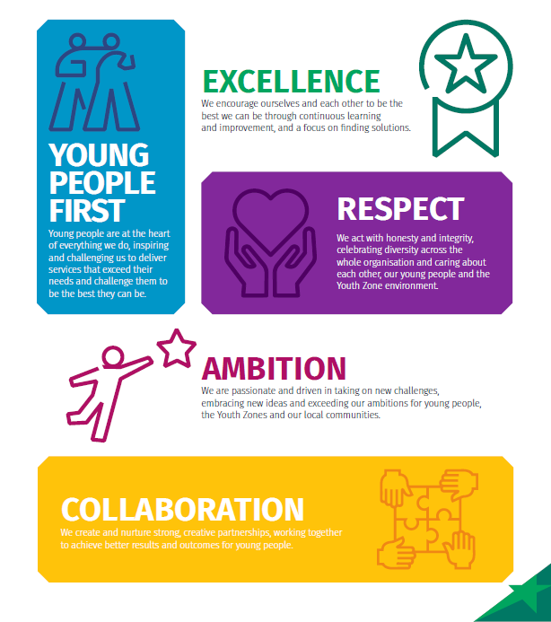
6

